Annie Lennard Primary school
Nursery – Year 1 Reading overview
Year 2-6 Whole class reading text overview
Intent
It is our intent that when our pupils leave their primary education they will:
- Be excellent communicators
- Be able to read any text they encounter fluently and with prosody and comprehend it at an age-appropriate level.
- Enjoy reading, read for pleasure and to have set the foundations for a lifelong love of reading.
- Have acquired a wide vocabulary, an understanding of grammar and knowledge of the linguistic conventions through reading.
- Appreciate our literary heritage.

At Annie Lennard Primary school, we use a text-based approach to our delivery of reading. It is our intent to fully immerse pupils in a class text as well as use isolated and unseen extracts so that such an in-depth study can:
- Provide the stimulus for the implementation of the National Curriculum for Reading and the Early Learning Goals for Literacy.
- Provide a seamless link between ‘readers as writers’ and ‘writers as readers’.
- Spark interest, curiosity and aspiration amongst pupils as readers and writers.
- Expose pupils who wouldn’t usually have access to a text beyond their reading band, to a text rich in vocabulary, characterisation and plot structure for example, in works of fiction; and to text rich in technical language, a variety of organisational structures and on diverse and thought-provoking themes for example, in non-fiction.
- Give pupils a chance to develop culturally, emotionally, intellectually, socially and spiritually through reading.
- To allow pupils to acquire new knowledge and to build on what they already know.
- Allow pupils to interact with a text over a sustained period of time.
- Allow pupils to apply their developing skills to unseen and isolated extracts, as they are asked to in the end of Key Stage statutory assessments.
- Promote reading for pleasure - a pure enjoyment of reading and a love of literature through widespread reading for enjoyment.
- Allow pupils to make links between texts studied.
- Expose pupils to ‘The Classics’, significant authors and new and up and coming writers and bold subject matter.
- Ensure a breadth of study between fiction, non-fiction and poetry.
- Broaden children’s vocabulary.
- Develop children’s linguistic knowledge, in particular of vocabulary and grammar.
- Ensure children can read fluently across any curriculum subject and set them up as life-long readers.

Early Years children are immersed in a focus text, using it as a basis to support cross-curricular learning. Children in Nursery are taught Foundations for phonics and children in Reception and Year 1 are taught Phonics using the Little Wandle validated scheme and have regular opportunities to apply their phonic knowledge to reading fully decodable books during Reading Practice (please see Phonics and Early Reading Policy).
The grid below sets out the focus texts studied across the year.
Class |  | Aut 1 |  |  | Aut 2 |  |  | Spr 1 |  | Spr 2 |  | Sum 1 | Sum 2
Nursery
Birth – 3
Pupils should be taught to:
- Enjoy songs and rhymes, tuning in and paying attention.
- Join in with songs and rhymes, copying sounds, rhythms, tunes and tempo.
- Say some of the words in songs and rhymes.
- Copy finger movements and other gestures.
- Enjoy sharing books with an adult.
- Sing songs and say rhymes independently, for example, singing whilst playing
- Pay attention and respond to the pictures or the words.
- Have favourite books and seek them out, to share with an adult, with another child, or to look at alone.
- Repeat words and phrases from familiar stories.
- Ask questions about the book. Make comments and shares their own ideas.
- Develop play around favourite stories using props
- Notice some print, such as the first letter of their name, a bus or door number, or a familiar logos.

Nursery age:
Pupils should be taught to:
- Understand the five key concepts about print:
- print has meaning
- print can have different purposes
- we read English text from left to right and from top to bottom
- the names of the different parts of a book
- page sequencing
- Develop their phonological awareness, so that they can:
- spot and suggest rhymes
- count or clap syllables in a word
- recognise words with the same initial sound, such as money and mother
- Engage in extended conversations about stories, learning new vocabulary
Reading |  | Ten Little Finger and Ten Little Toes by Mem Fox  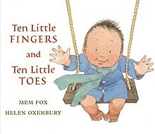  Where’s Lenny? By Ken Wilson-Max  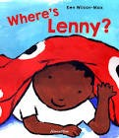  Reason for selection:  Little Wandle Introduction  Family References & Introduces number sequence  Topic – Babies  Reason for selection:  Cultural References & Introduces number sequence |  |  | Brown Bear, Brown Bear, What do you see? By Bill Martin Jr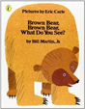  Topic – Senses & Celebrations  Reason for selection: Repetitive pattern and links to our senses.  World Nursery Rhyme Week also takes place this half term |  |  | Mrs Wishy-Washy's Farm by Joy Cowley & Elizabeth Fuller  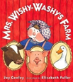  The three Little Pigs by DK and Giuseppe Di Lernia  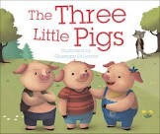  Topic – ‘Here and There’  Reason for selection:  Links to our topic and focus question – where? |  | The Hungry Caterpillar by Eric Carle  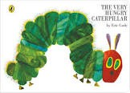  Topic – All Creatures Great and Small  Reason for Selection:  Science focus – life cycles. Introduces some non-fiction facts. |  | The Gingerbread Man by Lesley Sims  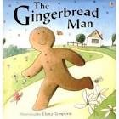  Topic – Food Glorious Food  Reason for selection:  Traditional Story linking to topic. | We’re Going on a Bear Hunt by Michael Rosen and Helen Oxenbury  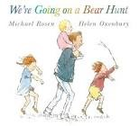  Topic – Let's go on a journey  Rosie’s walk by Pat Hutchins  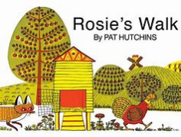  Reason for selection:  Repetitive pattern – talk for writing  Links to our topic and prepositional language
Reception
Reception age:
Pupils should be taught to:
- Read individual letters by saying the sounds for them
- Blend sounds into words, so that they can read short words made up of known letter-sound correspondences.
- Read some letter groups that each represent one sound and say sounds for them.
- Read a few common exception words matched to the school’s phonic programme.
- Read simple phrases and sentences made up of words with known letter–sound correspondences and, where necessary, a few exception words.
- Re-read these books to build up their confidence in word reading, their fluency and their understanding and enjoyment.
ELG Word Reading
Pupils should be taught to:
- Say a sound for each letter in the alphabet and at least 10 digraphs.
- Read words consistent with their phonic knowledge by sound-blending.
- Read aloud simple sentences and books that are consistent with their phonic knowledge, including some common exception words.
ELG Comprehension
Pupils should be taught to:
- Demonstrate understanding of what has been read to them by retelling stories and narratives using their own words and recently introduced vocabulary.
- Anticipate (where appropriate) key events in stories.
- Use and understand recently introduced vocabulary during discussions about stories, non-fiction, rhymes and poems and during role play.
Reading |  | Aut 1 |  | Aut 2 |  |  | Spr 1 |  | Spr 2 |  | Sum 1 |  | Sum 2
 |  | 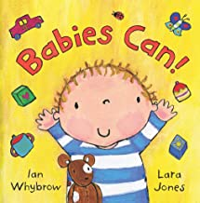  Babies can! By Ian Whybrow & Lara Jones  15 things not to do with a baby by Margaret McAllister & Holy Sterling  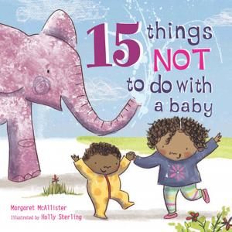  Topic – Babies  Reason for selection:  Transition – learning all about our new children. From when they were babies, to them at school now. Also learn about their families. |  | 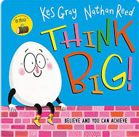  Think Big! by Kes Gray & Nathan Reed  Topic – Aspirations and Celebrations  Reason for selection:  Language used and illustrations. Familiar characters to the children.  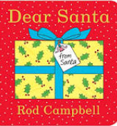  Topic – Christmas  Reason for selection:  Repetitive, simple language. Introducing describing language. Children create a class book like this one. |  |  | Otto the book bear by Katie Cleminson  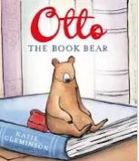  Topic – Here, There and Everywhere  Reason for selection:  Develops descriptive language we introduced last half term.  Lovely illustrations to begin to support children thinking imaginatively. |  | 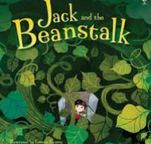  Jack & the beanstalk by Anna Milbounre and Lorenza Alvarez  Topic – Creatures Great and Small  Reason for selection:  Science focus – fairytale story which has a link to growing plants. |  | 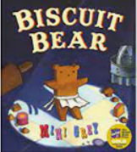  Biscuit Bear by Mini Grey  Topic – Food Glorious Food  Reason for selection:  Alternative take on a traditional tale. Repetitive language. Develops imaginative writing. |  | 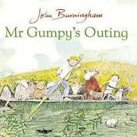  Mr Grumpy’s Outing by John Burningham  Topic – Let’s Go On A Journey  Reason for selection:  Developing use of simple conjunctions, such as ‘and’ and ‘but’
 |  | Little Wandle Guided Reading books – decoding, prosody, comprehension.
Year 1
Word reading
Pupils should be taught to:
- apply phonic knowledge and skills as the route to decode words
- respond speedily with the correct sound to graphemes (letters or groups of letters) for all 40+ phonemes, including, where applicable, alternative sounds for graphemes
- read accurately by blending sounds in unfamiliar words containing GPCs that have been taught
- read common exception words, noting unusual correspondences between spelling and sound and where these occur in the word
- read words containing taught GPCs and –s, –es, –ing, –ed, –er and –est endings
- read other words of more than one syllable that contain taught GPCs
- read words with contractions [for example, I’m, I’ll, we’ll], and understand that the apostrophe represents the omitted letter(s)
- read aloud accurately books that are consistent with their developing phonic knowledge and that do not require them to use other strategies to work out words
- re-read these books to build up their fluency and confidence in word reading.
Comprehension
Pupils should be taught to:
- develop pleasure in reading, motivation to read, vocabulary and understanding by:
- listening to and discussing a wide range of poems, stories and non-fiction at a level beyond that at which they can read independently
- being encouraged to link what they read or hear read to their own experiences
- becoming very familiar with key stories, fairy stories and traditional tales, retelling them and considering their particular characteristics
- recognising and joining in with predictable phrases
- learning to appreciate rhymes and poems, and to recite some by heart
- discussing word meanings, linking new meanings to those already known
- understand both the books they can already read accurately and fluently and those they listen to by:
- drawing on what they already know or on background information and vocabulary provided by the teacher
- checking that the text makes sense to them as they read and correcting inaccurate reading
- discussing the significance of the title and events
- making inferences on the basis of what is being said and done
- predicting what might happen on the basis of what has been read so far
- participate in discussion about what is read to them, taking turns and listening to what others say
- explain clearly their understanding of what is read to them.
Reading | Aut 1 start with x4 weeks of the place value of grammar and punctuation basic skills work. |  | Aut 2 |  |  | Spring |  |  |  |  | Sum 1 |  | Sum 2
 | 100 Dogs by Michael Whaite  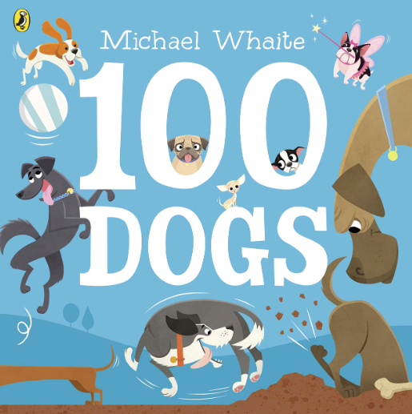  Reason for selection: Reinforcement and progression of basic skills work – nouns, subject of sentence and verbs. Introduction of adjectives.  Link to writing objectives.  Super Duper you by Sophy Henn 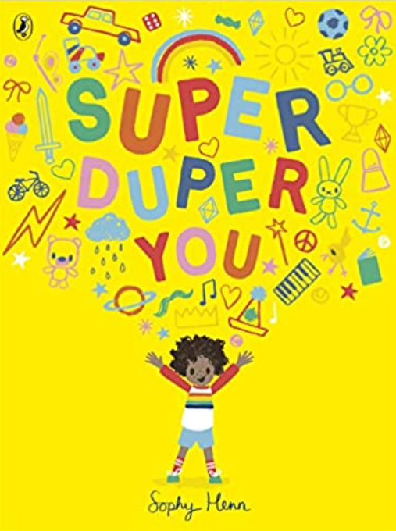  Reason for selection:  Transition to new class/teacher – learning about each other; PSHE link – identity, respecting differences, being unique, getting on and collaboration.  Link to writing objectives. |  | Lost and Found by Oliver Jeffers  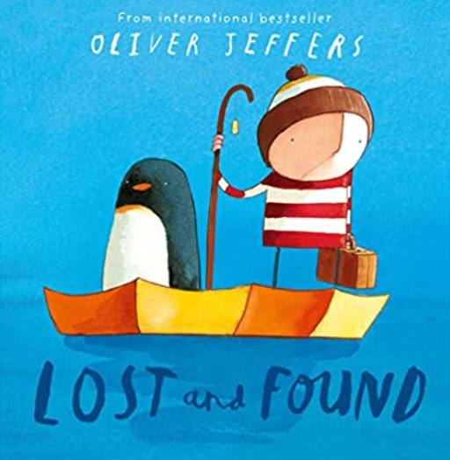  Reason for selection:  PSHE link – empathy, friendship.  Link to writing objectives.  Jonty Gentoo – The adventures of a penguin by Julia Donaldson  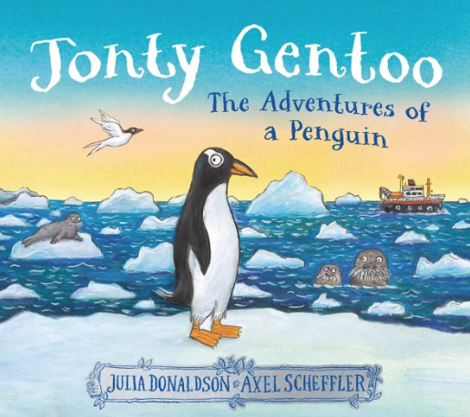  Reason for selection: poetry link; patterned language and rhyme. Science link – animals and their habitats.  Link to writing objectives.  Song of the train – David McCord  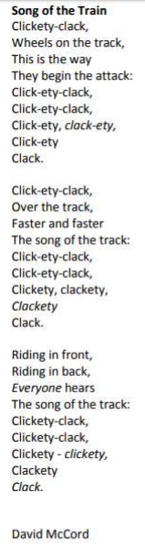 |  |  | Little Red Hen – Ladybird First favourite tales  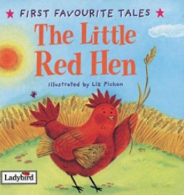  Reason for selection:  Building up traditional tale repertoire; repetitive and patterned language.  Link to writing objectives.  Little Red Riding Hood - Ladybird first favourite tales (one version to be studied not alternatives)  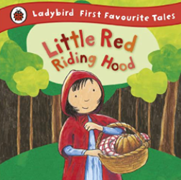  Reason for selection:  Building up traditional tale repertoire; repetitive and patterned language.  Link to writing objectives.  Handa’s surprise by Eileen Browne  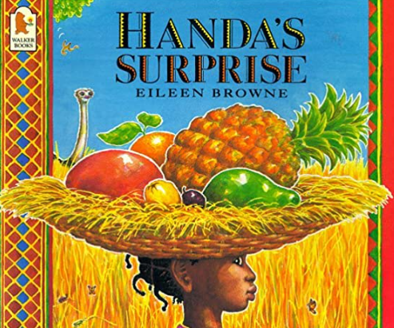  Reason for selection: stories from other cultures/traditions; modern classic; picture book; PSHE link – sharing and friendship.  Link to writing objectives.  The morning rush – John Foster  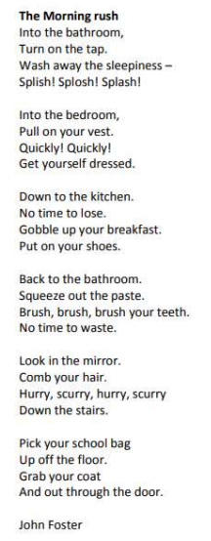 |  |  |  |  | Bog baby by Jeanne Wills & Gwen Millward  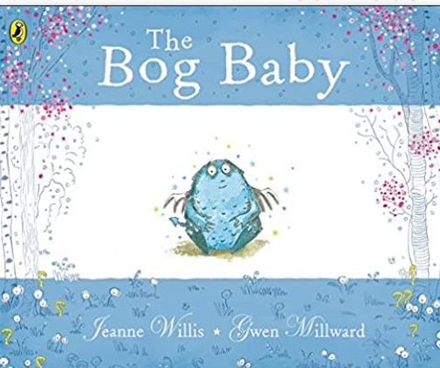  Reason for selection: PSHE link – looking after something, loss.  Link to writing objectives.  Cats – Eleanor Farjeon  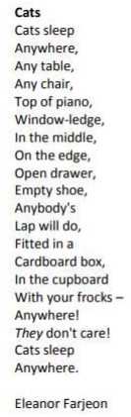 |  | The lighthouse keeper’s lunch by Ronda & David Armitage  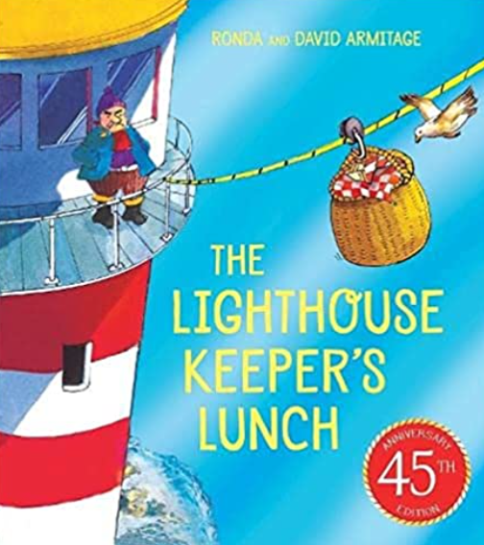  Reason for selection: Modern classic; adventure story; humorous story.  Link to writing objectives
Little Wandle Guided Reading books – decoding, prosody, comprehension.

Pupils in Year 2 continue Reading Practice sessions until they have finished learning phonics and are fluent enough to move to the Little Wandle Reading Fluency programme. The expectation is that children will be secure in Fluency 5 at the end of the year. Year 2 also begin to undertake whole class reading sessions, with a focus on developing early comprehension skills and instilling a lifelong love of reading. A variety of fiction, non-fiction and poetry texts are used in Reading Practice, Reading fluency and whole-class reading sessions.
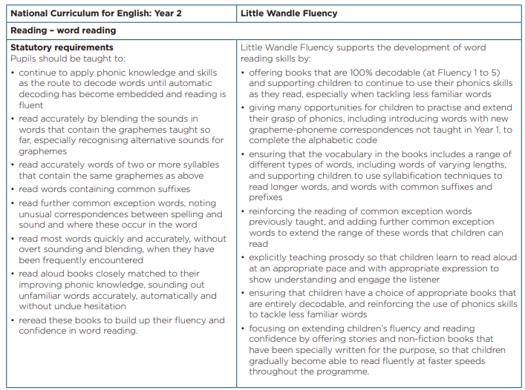

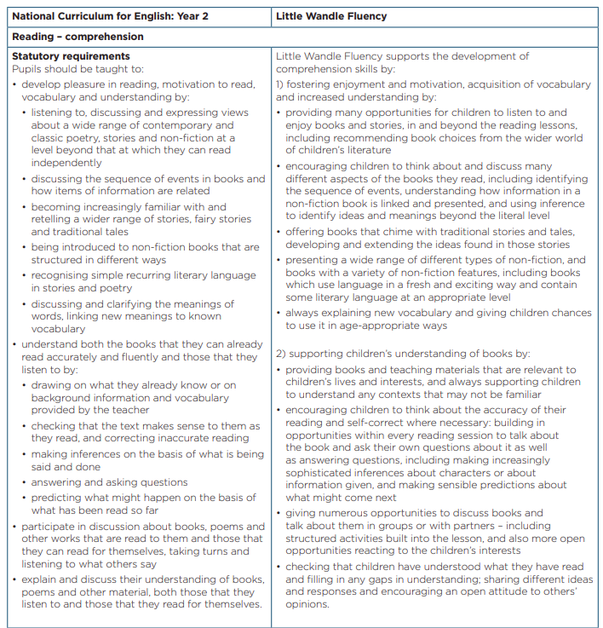
Reading Fluency programme | Fluency 1  60 wpm |  | Fluency 2  70 wpm | Fluency 3  80 wpm | Fluency 4  85 wpm | Fluency 5  90 wpm
 | 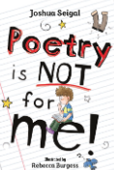  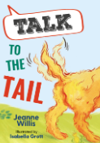  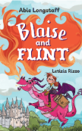  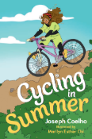 |  | 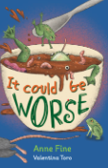  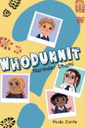  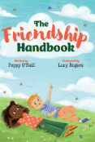  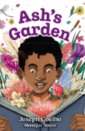 | 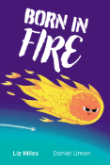  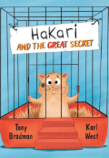  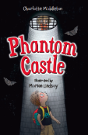  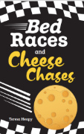 | 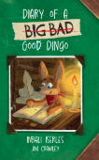  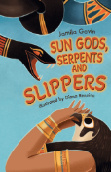  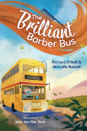  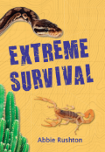 | 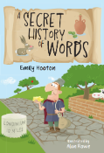  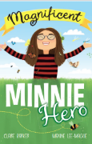  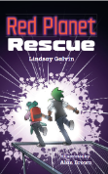  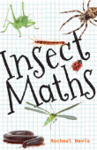
Word reading
Pupils should be taught to:
- continue to apply phonic knowledge and skills as the route to decode words until automatic decoding has become embedded and reading is fluent
- read accurately by blending the sounds in words that contain the graphemes taught so far, especially recognising alternative sounds for graphemes
- read accurately words of two or more syllables that contain the same graphemes as above
- read words containing common suffixes
- read further common exception words, noting unusual correspondences between spelling and sound and where these occur in the word
- read most words quickly and accurately, without overt sounding and blending, when they have been frequently encountered
- read aloud books closely matched to their improving phonic knowledge, sounding out unfamiliar words accurately, automatically and without undue hesitation
- re-read these books to build up their fluency and confidence in word reading.
Comprehension
Pupils should be taught to:
- develop pleasure in reading, motivation to read, vocabulary and understanding by:
- listening to, discussing and expressing views about a wide range of contemporary and classic poetry, stories and non-fiction at a level beyond that at which they can read independently
- discussing the sequence of events in books and how items of information are related
- becoming increasingly familiar with and retelling a wider range of stories, fairy stories and traditional tales
- being introduced to non-fiction books that are structured in different ways
- recognising simple recurring literary language in stories and poetry
- discussing and clarifying the meanings of words, linking new meanings to known vocabulary
- discussing their favourite words and phrases
- continuing to build up a repertoire of poems learnt by heart, appreciating these and reciting some, with appropriate intonation to make the meaning clear
- understand both the books that they can already read accurately and fluently and those that they listen to by:
- drawing on what they already know or on background information and vocabulary provided by the teacher
- checking that the text makes sense to them as they read and correcting inaccurate reading
- making inferences on the basis of what is being said and done
- answering and asking questions
- predicting what might happen on the basis of what has been read so far
- participate in discussion about books, poems and other works that are read to them and those that they can read for themselves, taking turns and listening to what others say
explain and discuss their understanding of books, poems and other material, both those that they listen to and those that they read for themselves.

Whole class reading |  | Aut 1 | Aut 2 | Spr 1 | Spr 2 | Sum 1 | Sum 2
Fiction/non-fiction |  | Grandad’s island by Benji Davies  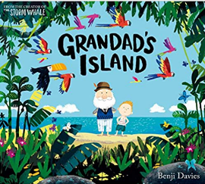  Literary form: fiction  Reason for selection:  Contemporary fiction. PSHE link – loss and grief  Links to writing objectives.  Yuval Zommer  The big book of the blue  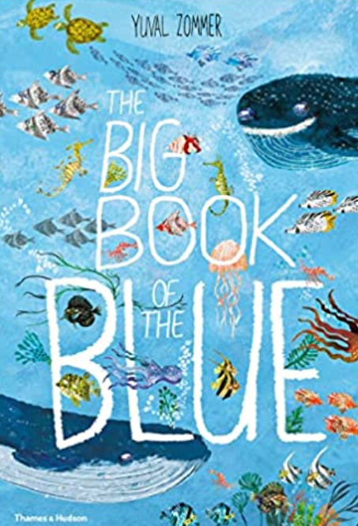  Literary form: non fiction  Reason for selection: Contemporary non-fiction.  Geography/Science link – animals, habitats. | Chris Van Allsburg  The Polar Express  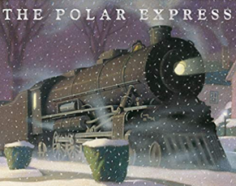  Literary form: fiction  Reason for selection: Christmas classic.  Links to writing objectives. | Vlad and the Great Fire of London – Kate Cunningham  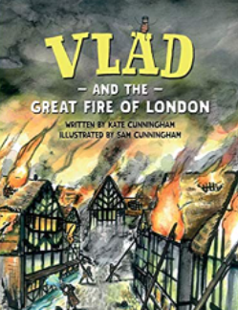  Literary form: fiction & non-fiction  Reason for selection:  Link to The Great Fire of London | Anthony Browne  Hansel and Gretel  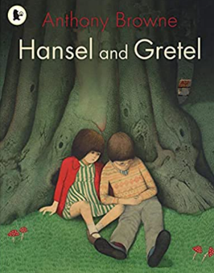  Literary form: fiction  Reason for selection: significant author. Traditional tale | The selfish giant by Oscar Wilde – illustrated version – Alexis Deacon  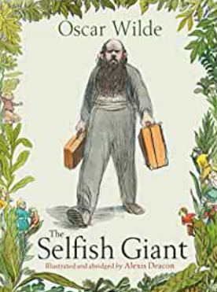  Literary form: fiction  Reason for selection: Classic author. Fairytale. PSHE link – love, sharing and forgiveness. | Man on the moon by Simon Bartram 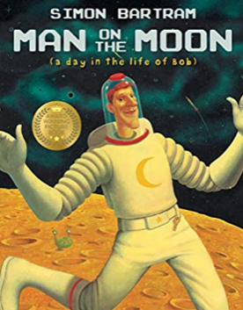 Literary form: fiction  Reason for selection: high quality picture book. Humorous narrative.  Tim Hopgood  My big book of outdoors 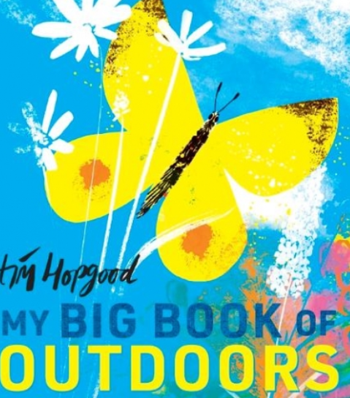  Literary form: non fiction  Reason for selection: Science/Geography link - seasons
Poetry (1 week per half term) |  | The proper way to meet a hedgehog and other how to poems  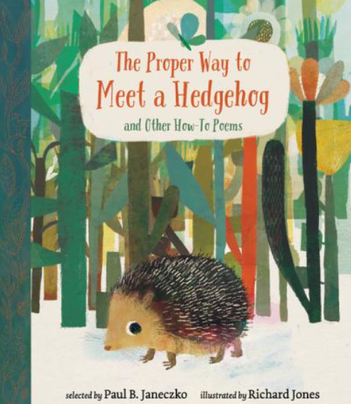  Literary form: Contemporary and classic poetry – Kwame Alexander, Niki Grimes, Christina Rosetti, Robert Louis Stevenson  Reason for selection: PSHE link – feelings. Art and design link. Classic and contemporary poets. |  | The Puffin book of Fantastic first poems  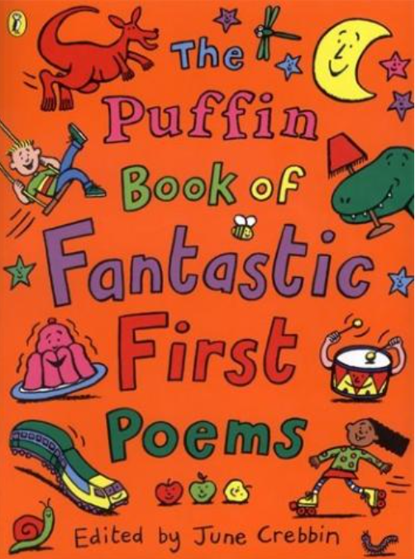  Literary form: Rhyme and song poetry.  Reason for selection: modern, classic and traditional poetry. |  | Chosen by Julia Donaldson  Poems to perform – a classic collection  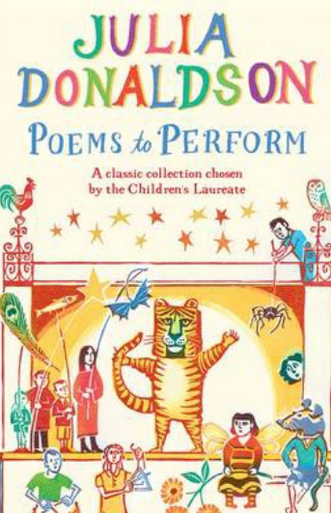  Literary form: Rhythm and rhyme. Classic poetry.  Reason for selection: Classic poetry. Reciting poems by heart and performance poetry.

Pupils in Years 3-6 undertake whole class reading using a variety of fiction, non-fiction and poetry whole class texts. These are outlined below.
In addition to the class texts, children retrieve, apply and embed their skills when working with isolated and unseen extracts across a breadth of fiction, non-fiction and poetry. Please see the Reading policy for further detail.
Year 3 and 4
Word reading
Pupils should be taught to:
- apply their growing knowledge of root words, prefixes and suffixes (etymology and morphology) as listed in English Appendix 1, both to read aloud and to understand the meaning of new words they meet.
- read further exception words, noting the unusual correspondences between spelling and sound, and where these occur in the word.

Comprehension
Pupils should be taught to:
- develop positive attitudes to reading and understanding of what they read by:
- listening to and discussing a wide range of fiction, poetry, plays, non-fiction and reference books or textbooks
- reading books that are structured in different ways and reading for a range of purposes
- using dictionaries to check the meaning of words that they have read
- increasing their familiarity with a wide range of books, including fairy stories, myths and legends, and retelling some of these orally
- identifying themes and conventions in a wide range of books
- preparing poems and play scripts to read aloud and to perform, showing understanding through intonation, tone, volume and action
- discussing words and phrases that capture the reader’s interest and imagination
- recognising some different forms of poetry [for example, free verse, narrative poetry]
- understand what they read, in books they can read independently, by:
- checking that the text makes sense to them, discussing their understanding and explaining the meaning of words in context
- asking questions to improve their understanding of a text
- drawing inferences such as inferring characters’ feelings, thoughts and motives from their actions, and justifying inferences with evidence
- predicting what might happen from details stated and implied
- identifying main ideas drawn from more than one paragraph and summarising these
- identifying how language, structure, and presentation contribute to meaning
- retrieve and record information from non-fiction
- participate in discussion about both books that are read to them and those they can read for themselves, taking turns and listening to what others say
Reading | Aut 1 |  | Aut 2 | Spr 1 | Spr 2 |  | Sum 1 | Sum 2
Fiction/non-fiction | Jess French  The Book of Brilliant Bugs  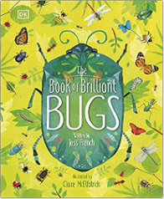  Literary form:  Non-fiction  Reason for selection: Science link.  Dianna Hutts Aston  A rock is lively  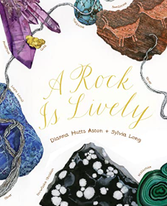  Literary form:  Non-fiction  Reason for selection: Science link and link to Stone Age Boy writing stimulus text and Stone Age in History. | Geraldine McCaughrean  The Orchard book of Greek myths  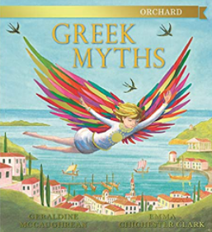  Literary form: myths and legends  Reason for selection: myths and legends.  Swap this to Summer 1 next year and replace with The boy who grew dragons |  | Ted Hughes  Iron Man  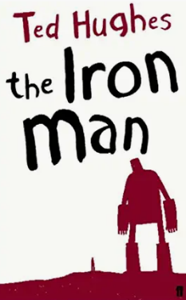  Literary form: fiction  Reason for selection: Significant author. Classic. Links to writing text. | The Wild Robot  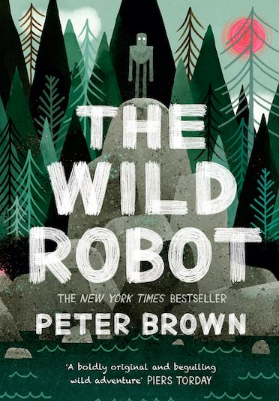  Literary form: fiction  Reason for selection: Modern day Iron Man. Contemporary fiction. |  | This morning I met a whale by Michael Morpurgo  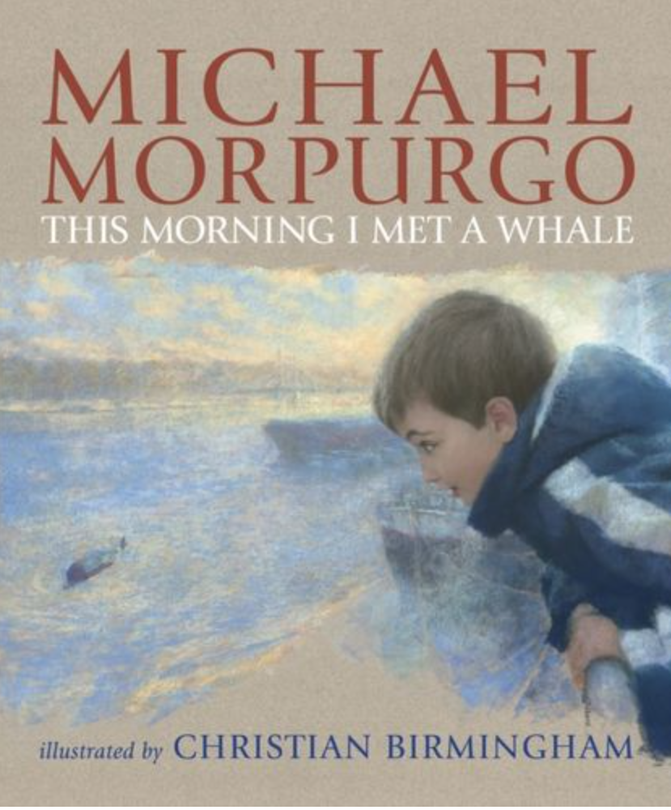  Literary form: fiction  Reason for selection: Significant author. Links to writing text. | Anna Claybourne Killer plants and other Green Gunk  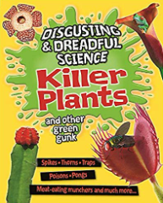  Literary form: Non-fiction  Reason for selection: Science link. Links to writing text.
Poetry (1 week per half term) | Compiled by John Foster  The Universal Vacuum Cleaner  ‘What’s There?’  Page 3  ‘Creature of fable’  Page 45  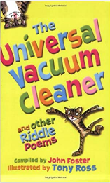  Literary form: riddle poems.  Reason for selection: Riddle poems. Language rich. |  | Edward Lear  The Owl and the Pussycat  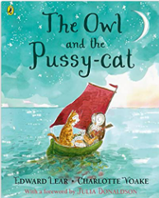  Literary form: narrative poem.  Reason for selection: Classic poem. Narrative poem. | The Puffin Book of Utterly Brilliant Poetry.  ‘The Squirdle’ Page 15  ‘On the Ning, Nang, Nong’  Page 18  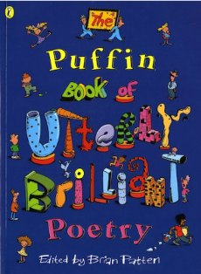  Literary form: Rhyme. Ryhthm. Nonsense/comic poems.  Reason for selection: Humour and enjoyment – comic/nonsense poems. Significant poets – Spike Milligan | Valerie Bloom  Stars with flaming tails  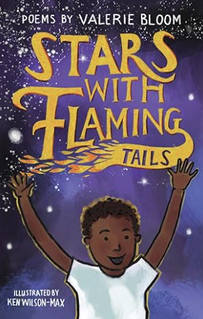  Literary form: wide variety of poetic forms from elfje to limericks. Performance poetry.  Reason for selection: Significant performance poet – Valerie Bloom. Wide range of poetic forms. |  | New Poems Inspired by Art in the Tate  By Grace Nichols  Paint Me a Poem:  ‘The Dance’  Page67  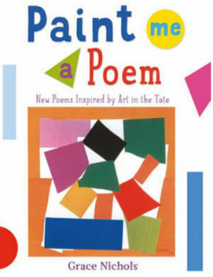  Literary form: vivid imagery. Figurative language.  Reason for selection: Significant poet. Links to elements of Art. Year 3 recommended read by Pie Corbett poetry spine | James Carter  The World’s greatest Space Cadet  Sunrise – Sunwise,  Page 66  The Light, Page 37  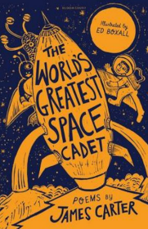  Literary form: Narrative poems  Reason for selection: Science link – Light.  Contemporary poet
Plus X2 a week – isolated extracts/unseen texts, linked through a particular theme each week. This ensures we deliver a range of fiction, poetry, plays, non-fiction, reference and textbooks, fairy stories, myths and legends.
Year 4
Reading | Aut 1 |  | Aut 2 | Spr 1 | Spr 2 |  | Sum 1 | Sum 2
Fiction/non-fiction | Onjali Q. Raúf  The Boy at the Back of the Class  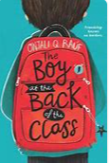  Literacy form:  Fiction Novel  Reason for selection: Contemporary fiction. Recommended read. Links to PSHE - diversity and inclusion. Relevant to cultural context of the school/pupils’ environment. |  | Roald Dahl  Charlie and the chocolate factory  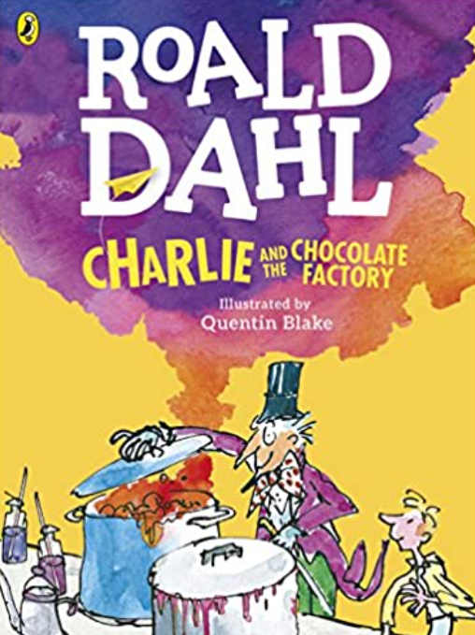  Literary form:  Fiction Novel  Reason for selection: Significant author. Humorous and engaging for pupils. Writing stimulus text too. | Jess French  It’s a Wonderful World  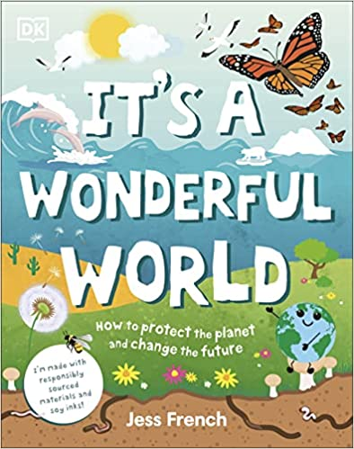  Literary form: Non-fiction text  Reason for selection: Science & Geography links – animals and their habitats, environmental issues.  Isabel Thomas for DK books  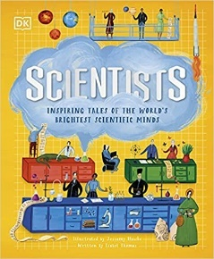  Scientists  Literary form:  Non-fiction, biographies  Reason for selection: Links to STEM topics. Promotes gender equality. | Michaeal Morpurgo  Butterfly Lion  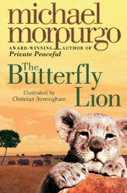  Literary form:  Fiction Novel  Reason for selection: Significant author. Classic fiction. Language rich. |  | Mia Cassany  Majestic mountains: discover Earth’s mighty peaks  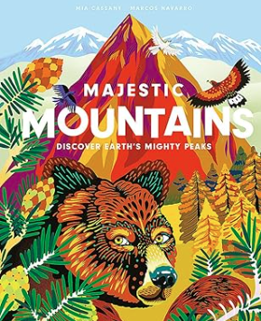  Literary form: non-fiction  Reason for selection: Geography link to Earth science – mountains and volcanoes | CS Lewis  The Lion, The Witch and the Wardrobe  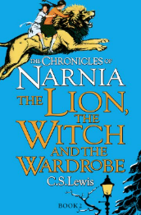  Literary form: Fantasy Fiction novel  Reason for selection: significant author. Classic fiction.  Folklore and fairy tale links.  slavery issues. Rich and varied vocabulary.
Poetry (1 week per half term) | Wes Magee  Deep in the Green Wood  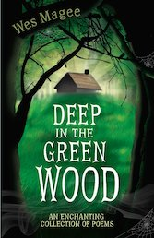  Literary form: Short poems. Descriptive poems. Language rich.  Reason for selection: Linked themes for shorter poems. Spooky poems building towards Halloween and winter time. Year 4 recommended read by Pie Corbett poetry spine. |  | Joshua Seigal  Welcome to my Crazy Life  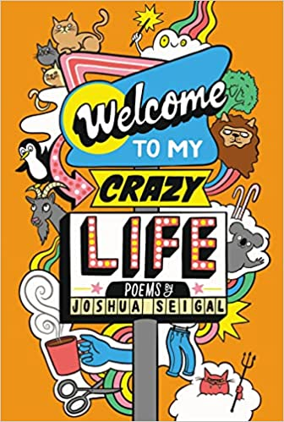  Literary form: Homourus poems. Rhythm and rhyme.  Reason for selection: comic poetry for pupil interest and engagement. Contemporary poet. New release. | Valerie Bloom  Hot like Fire and Other Poems  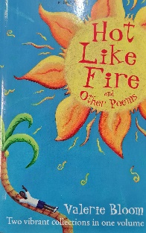  Literary form: Performance poetry.  Reason for selection: renowned performance poet – poems to read aloud and perform. Year 4 recommended read by Pie Corbett poetry spine. | John Agard  Hello H2O  Poems  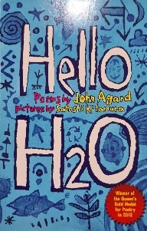  Literary form: Humorous poems. Narrative poetry. Rhyme.  Reason for selection: Science and geography links. Contemporary poetry. Significant poet – Queens Gold Medal for Poetry winner in 2012 and Book Trust’s Lifetime Achievement award in 2021. Year 4 recommended read by Pie Corbett poetry spine. |  | Joseph Coehlo  Werewolf club rules  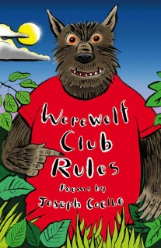  Literary form: Humorous poems. Word play. Rhyme. Rhythm.  Reason for selection: PSHE link - relationships and identity. Winner of the CLIPPA poetry award. | Chosen by Roger McGough  SENSATIONAL! Poems inspired by the five senses  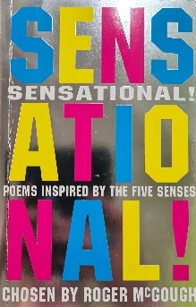  Literary form: Variety of poetry forms.  Reason for selection: Significant poets. Award winning. Links to science topics. Year 4 recommended read by Pie Corbett poetry spine.
Plus X3 a week – isolated extracts/unseen texts, linked through a particular theme each week. This ensures we deliver a range of fiction, poetry, plays, non-fiction, reference and textbooks, fairy stories, myths and legends.
Year 5 and 6
Word Reading
Pupils should be taught to:
- apply their growing knowledge of root words, prefixes and suffixes (morphology and etymology), as listed in English Appendix 1, both to read aloud and to understand the meaning of new words that they meet

Comprehension
Pupils should be taught to:
- maintain positive attitudes to reading and understanding of what they read by:
- continuing to read and discuss an increasingly wide range of fiction, poetry, plays, non-fiction and reference books or textbooks
- reading books that are structured in different ways and reading for a range of purposes
- increasing their familiarity with a wide range of books, including myths, legends and traditional stories, modern fiction, fiction from our literary heritage, and books from other cultures and traditions
- recommending books that they have read to their peers, giving reasons for their choices
- identifying and discussing themes and conventions in and across a wide range of writing
- making comparisons within and across books
- learning a wider range of poetry by heart
- preparing poems and plays to read aloud and to perform, showing understanding through intonation, tone and volume so that the meaning is clear to an audience
- understand what they read by:
- checking that the book makes sense to them, discussing their understanding and exploring the meaning of words in context
- asking questions to improve their understanding
- drawing inferences such as inferring characters’ feelings, thoughts and motives from their actions, and justifying inferences with evidence
- predicting what might happen from details stated and implied
- summarising the main ideas drawn from more than one paragraph, identifying key details that support the main idea
- identifying how language, structure and presentation contribute to meaning
- discuss and evaluate how authors use language, including figurative language, considering the impact on the reader
- distinguish between statements of fact and opinion
- retrieve, record and present information from non-fiction
- participate in discussions about books that are read to them and those they can read for themselves, building on their own and others’ ideas and challenging views courteously
- explain and discuss their understanding of what they have read, including through formal presentations and debates, maintaining a focus on the topic and using notes where necessary
- provide reasoned justifications for their views
Reading | Aut 1 |  | Aut 2 | Spr 1 | Spr 2 |  | Sum 1 | Sum 2
Fiction/non-fiction | Michael Morpurgo  Kensuke’s Kingdom  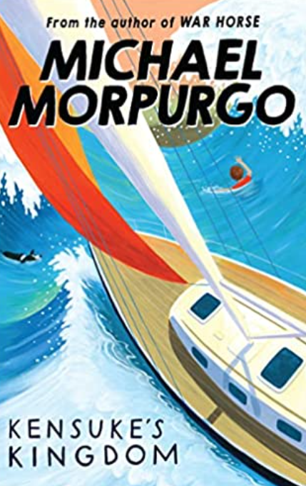  Literary form: Fiction. Adventure story.  Reason for selection: Significant author. |  | Polly Hoe-Yen  The boy in the tower  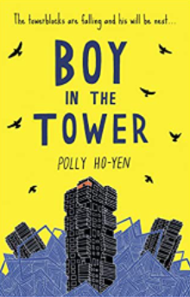  Literary form:  Contemporary fiction  Reason for selection: PSHE link - human theme. Writing stimulus text too. | R.J. Palacio  Wonder  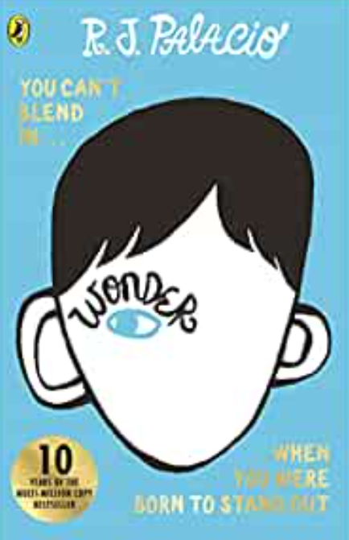  Literary form: contemporary fiction  Reason for selection: PSHE link – human theme |  |  | Beowulf  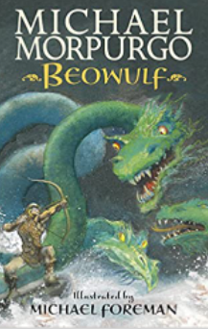  Literary form:  Fiction. Myths and legends.  Reason for selection: Myths and legends. Significant author. History link - Vikings
 | Floella Benjamin  Coming to England: An inspiring true story celebrating the Windrush generation  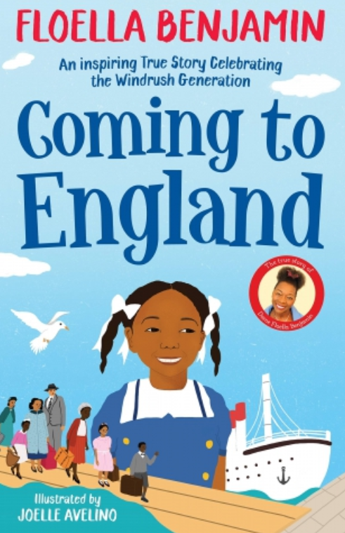  Literary form: Non-Fiction  Reason for selection: History link – black history month. PSHE link – family, feelings, equality, identity, diversity. |  |  | Noel Zone  Danger is everywhere: a handbook for avoiding danger  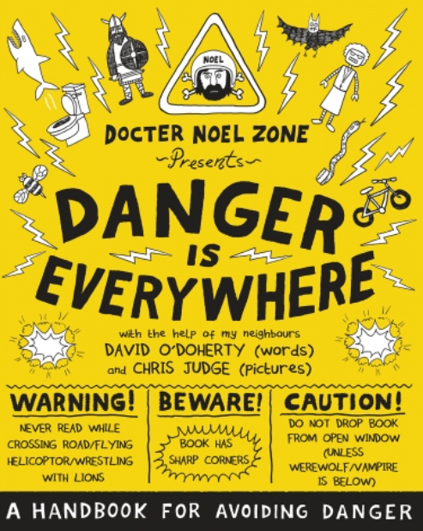  Literary form: Non-Fiction. Handbook.  Reason for selection: Links to Art & Design. Handbook. Contemporary author. | Katherine Johnson: A life story  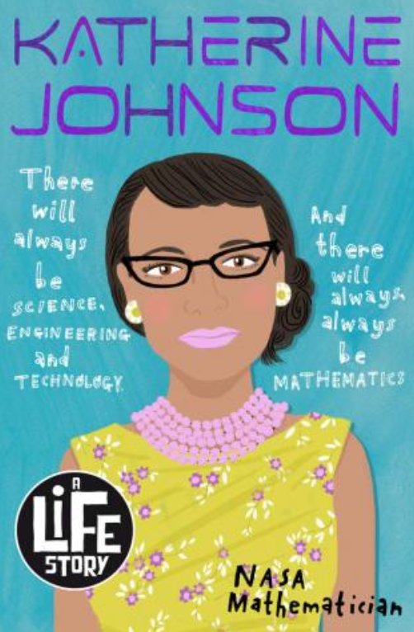  Literary form: Non fiction biography.  Reason for selection: History link – Black history, women’s history. PSHE link – gender equality, identity. Science link – Space and the solar system. |  | Rachel Ignotofsky  Women in Science  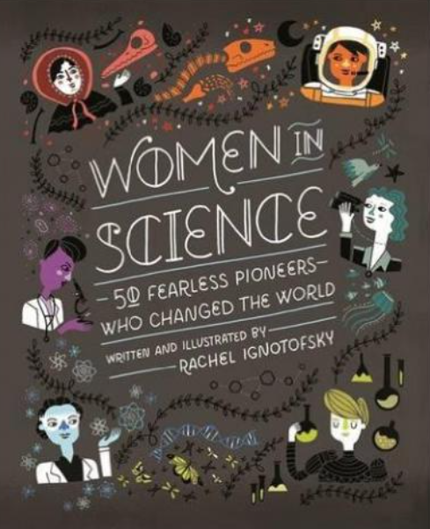  Literary form: Non-Fiction  Reason for selection: PSHE link – equality, high aspirations. Science link. School demographic – ethnic groups. Challenging stereotypes.  Michael Morpurgo |  | Inspired by David Attenborough's series The Green Planet  The Green planet: for young wildlife lovers.  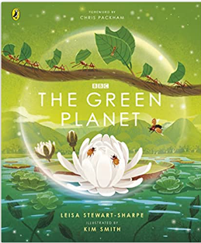 Literary form: Non-Fiction  Reason for selection: Geography/science link – Earth, environmental issues, humans and animals.
Poetry (1 week per half term) | Chosen by Nikita Gill  Slam! You’re gonna wanna hear this!  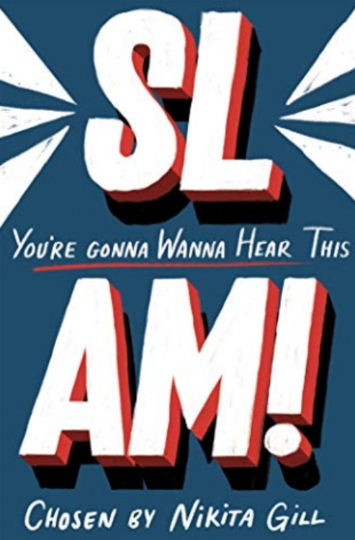  Literary form: slam poetry.  Reason for selection: International spoken word/performance poet. Contemporary poetry. Up and coming poets. Performance poetry. |  | Edward Lear  The Complete Nonsense of Edward Lear  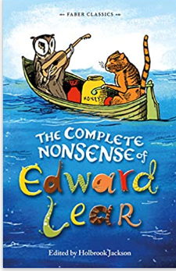  Literary form: Nonsense poems.  Reason for selection: Classic poetry. Significant poet. | Karl Nova  Rhythm and Poetry  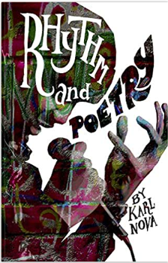  Literary form:  Rap poetry. Performance poetry. Rhythm. Rhyme. Song.  Reason for selection: Contemporary poetry. Rap poetry. |  |  | Edited by John Agard & Grace Nicholls  A Caribbean dozen  What the teacher said when asked: what er we ‘avin for Geography Miss?  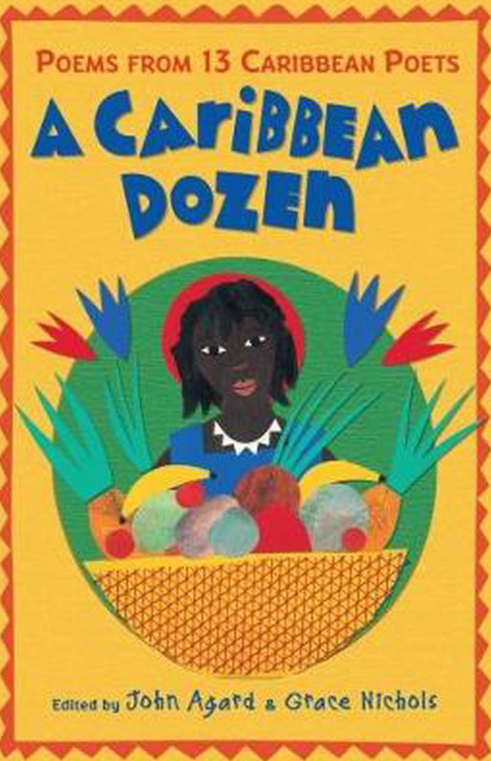  Literary form: Humorous poetry. Rhyme. Rhythm. Word play.  Reason for selection: Poetry from other cultures and traditions. | Liz Brownlee  Matt Goodfellow  Laura Mucha  Being Me: Poems About Thoughts, Worries and Feelings  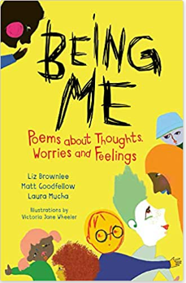  Literary form: Range of poetic forms. Refrains. Assonance. Metaphors. Rhyme. Rhythm. Imagery  Reason for selection: PSHE link – family, feelings, growing and changing. Contemporary poets.
Year 6
Reading | Aut 1 |  | Aut 2 | Spr 1 | Spr 2 |  | Sum 1 | Sum 2
Fiction/non-fiction | Phil Earle  When the sky falls  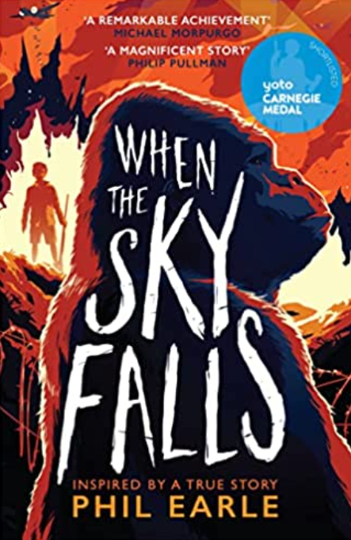  Literary form: historical fiction  Reason for selection: History link – WWII. Writing stimulus text too.  David Olusoga  Black and British: an illustrated history  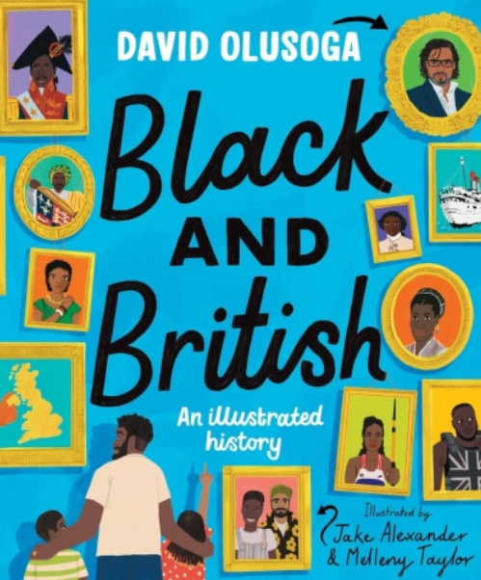  Literary form: non fiction. Reference book.  Reason for selection: forgotten/eclipsed history. Links to history and national celebrations – Black History Month. PSHE link – equality, identity and diversity. |  | Leon Garfield  Shakespeare stories  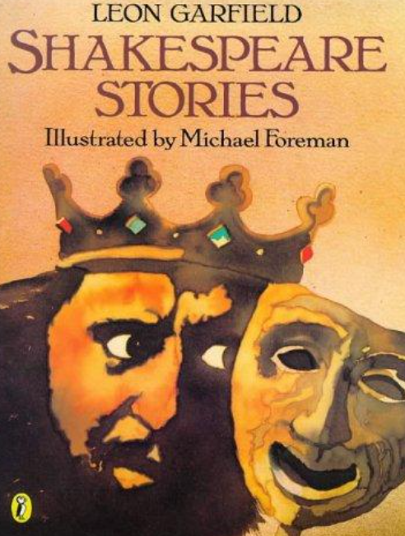  Literary form: Plays presented in narrative form.  Reason for selection: Introduction to the works of Shakespeare.  The missing: the true story of my family in World War II  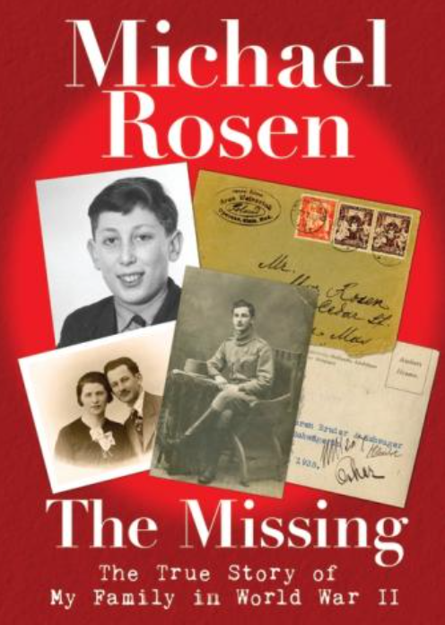  Literary form: non fiction  Reason for selection: History link – WWII. Significant author. | Louis Sarchar  Holes  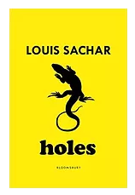  Literary form: young adult fiction  Reason for selection: PSHE link – human theme | Andy Mulligan  Trash  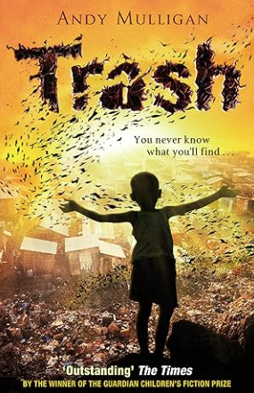  Literary form: young adult fiction  Reason for selection: PSHE link – poverty, self-reliance, resilience |  | David Almond  Skellig  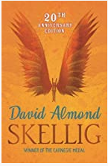  Literary form: Fantasy novel.  Reason for selection: Significant author.  Science links – evolution, animals and their habitats, life cycles.  Anna Claybourne  Amazing Evolution- the journey of life  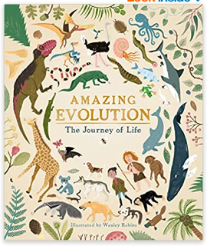  Literary form: non-fiction  Reason for selection: Science link – introduction to evolution.
Poetry (1 week per half term) | Michael Rosen  On the move: poems about migration  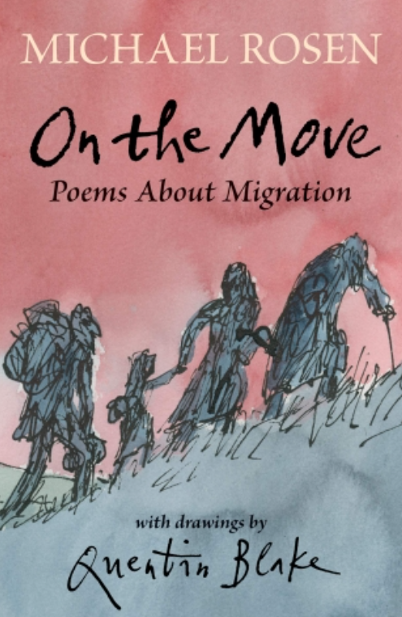  Literary form: Narrative poems. Assonance. Repetition. Refrains. Rhythm.  Reason for selection: significant poet. PSHE links – identity, equality, human themes – refugee experiences. History link – the world wars. |  | Joseph Coelho  Overhead in a tower block  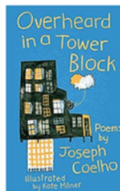  Literary form: Variety of poetic forms linked to fantasy, story, myth and magic. Rhyme and song.  Reason for selection: PSHE link – empathy and kindness, family and feelings, growing and changing. | Robert Macfarlane The Lost Words  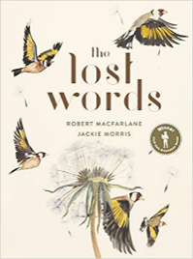  Literary form: nature poetry. Acrostic. Rhyme and song.  Reason for selection: restore vanishing poetry of nature. Science link – animals and habitats. |  | Compiled by Michael Rosen.  Classic Poetry  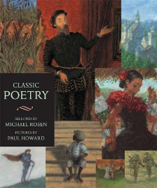  Literary form: Classic poetry.  Reason for selection: Classic poetry. Significant authors.
Plus X3 a week – isolated extracts/unseen texts, linked through a particular theme each week. This ensures we deliver a range of fiction, poetry, plays, non-fiction, reference and textbooks, myths, legends, traditional stories, modern fiction, fiction from our literary heritage and books from other cultures and traditions.

